
Harper Adams University
Scientific Data Policy
2025

September 2025

Harper Adams Scientific Data Policy

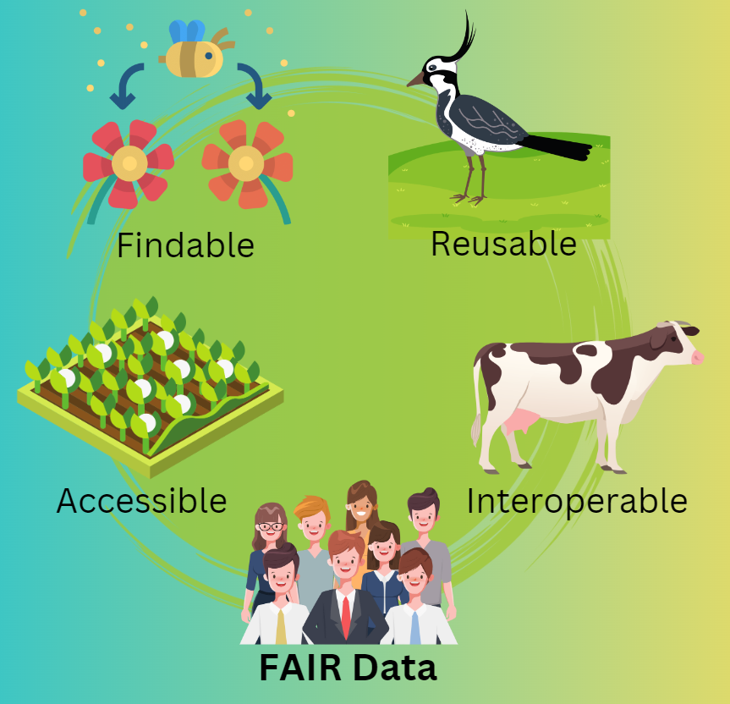

Introduction
Harper Adams University stands at the forefront of agricultural education and research, deeply committed to advancing knowledge and fostering innovation within the sector. Recognising the pivotal role that data plays in these endeavours, the University operates facilities such as the Harper Adams Future Farm, which serve as an essential resource for both research and teaching. The generation and responsible management of data are integral to the University's mission, underpinning its contributions to the agricultural community and society at large.
This Research Data Policy establishes a comprehensive framework for the management of research data at Harper Adams University. Aligned with the FAIR principles (Findable, Accessible, Interoperable, and Reusable) the policy ensures that data generated from various sources are systematically curated, maintained in an orderly state, and made accessible and open where appropriate. By formalizing data management practices, the University seeks to enhance transparency, facilitate collaboration, and maximize the impact of its research outputs.
The policy applies to all research data produced under the auspices of Harper Adams University. This encompasses data from the Future Farm intended for open and accessible teaching and research both within and outside the University. It includes data associated with Long Term Experiments such as the Traffic and Tillage Experiment, the Hands Free Farm, and the Conservation Agriculture Strip-Farming Experiment. Additionally, it covers data generated from research projects conducted by faculty and postgraduate research students, as well as datasets arising from taught student work, specifically Research Projects at the BSc and MSc levels.
The primary objectives of this policy are to promote data excellence by ensuring that all research data are managed to the highest standards of quality and integrity. It aims to facilitate open access by encouraging the sharing of data in a manner that is as open as possible while respecting legal, ethical, and commercial constraints. The policy seeks to enhance collaboration by supporting interdisciplinary and cross-institutional research through readily available data. It ensures compliance with all applicable laws, regulations, and ethical guidelines concerning data protection and intellectual property. Furthermore, it supports education and innovation by utilizing data as a resource for teaching, learning, and the development of new technologies and methodologies in agriculture. By adhering to these objectives, Harper Adams University reaffirms its dedication to responsible data stewardship and its role as a leader in agricultural research and education.

Principles
FAIR Data Principles
The FAIR Data Principles are a set of guidelines designed to make research data more valuable and impactful. They focus on four key aspects:
Findable: Data should be easy to discover through clear metadata and persistent identifiers.
Accessible: Once found, data should be retrievable using standardized protocols.
Interoperable: Data should use common formats and vocabularies to allow integration with other datasets.
Reusable: Data should be well-described and licensed to enable reuse in various contexts. These principles aim to enhance the ability of machines and humans to automatically find and use data, thus supporting knowledge discovery and innovation.

Further Reading:
Wilkinson, M. D., et al. (2016). The FAIR Guiding Principles for scientific data management and stewardship. Scientific Data, 3, 160018.
GO FAIR Initiative. (2024). FAIR Principles.

This policy is grounded in the commitment of Harper Adams University to uphold the highest standards of research data management. Central to this commitment are the: Data should be Findable, Accessible, Interoperable, and Reusable. These principles serve as the cornerstone for all data-related activities within the University. By adhering to these principles, the University ensures that research data are systematically organised and documented in a manner that facilitates discovery and retrieval by both internal and external stakeholders.
The Findability of data is enhanced through meticulous cataloguing and the use of standardised metadata, such as defining variable definitions within a dataset and curating a standardised description of the data source. This allows for efficient data identification and access. Accessibility is a fundamental aspect of this policy, wherein the University strives to make research data available to the widest possible audience while respecting legal, ethical, and commercial considerations. Access protocols are established to provide clarity on how data can be obtained, ensuring that users are aware of any conditions or restrictions that may apply. Interoperability is achieved by employing standardized data formats and protocols, enabling seamless integration and use across different systems and platforms. This fosters collaboration and supports interdisciplinary research by allowing data to be combined and compared with other datasets. Reusability is promoted through comprehensive documentation and the provision of clear usage licenses, ensuring that data can be confidently utilised in future research endeavours without ambiguity regarding permissions or limitations.
Ethical and legal compliance is paramount in all aspects of research data management at Harper Adams University. The policy mandates strict adherence to all applicable laws and regulations, including data protection legislation and intellectual property rights. Researchers and students are required to conduct their data activities in accordance with ethical standards that safeguard the rights, privacy, and welfare of any individuals or entities involved. This includes obtaining necessary consents, maintaining confidentiality where appropriate, and ensuring that data handling practices do not infringe upon the legal rights of others. The University is committed to fostering a culture of integrity and responsibility, providing guidance and support to ensure that all data-related activities are conducted in an ethical and lawful manner.

Data Sources
Harper Adams University recognises the diversity and significance of various data sources that underpin its research and educational activities. This policy addresses the management of data originating from several key sources within the University, each presenting unique considerations and requirements. By providing clear guidelines for these data sources, the University ensures a consistent and effective approach to data management that aligns with its strategic objectives.
Data from the Future Farm are intended to be open and accessible for teaching and research purposes both within the University and to external stakeholders. This data serves as a valuable resource for advancing agricultural practices and education. The University is committed to managing Future Farm data in a manner that promotes openness while ensuring data integrity and quality. Measures are implemented to facilitate easy access, support collaborative efforts, and promote the dissemination of knowledge across the agricultural sector.
Long Term Experiments, such as the Traffic and Tillage Experiment, the Hands Free Farm, and the Conservation Agriculture Experiment, generate extensive datasets critical for longitudinal studies and the advancement of agricultural science. The management of data from these experiments requires careful consideration to preserve continuity and reliability over time. The policy mandates meticulous curation and secure storage of data from these experiments, with established protocols governing access and sharing. While the University encourages the use of this data for research and educational purposes, access may be subject to specific conditions to protect the integrity of ongoing experiments and to comply with ethical or legal obligations.
Data generated from research projects conducted by faculty and postgraduate research students constitute another significant source. This data often involves innovative methodologies and may include sensitive or proprietary information. The policy outlines the responsibilities of researchers in managing their data, emphasising the importance of data quality, security, and compliance with relevant regulations. Researchers are expected to document their data thoroughly, ensuring that it is maintained in an orderly and accessible manner. They must also consider the potential for data sharing and reuse, balancing openness with confidentiality or intellectual property considerations.
Datasets arising from taught student work, specifically Honours Research Projects at the BSc level and Master’s Research Projects at the MSc level, are also encompassed by this policy. The University recognises the educational value of engaging students in rigorous data management practices. Students are guided to maintain their datasets in accordance with the principles outlined in this policy, ensuring that their work contributes meaningfully to the collective knowledge base. Access to student-generated data may be facilitated for educational purposes, subject to any confidentiality agreements or ethical considerations pertinent to their research.
By delineating specific requirements and expectations for each data source, this policy ensures a cohesive approach to data management across the University. This fosters an environment where data is valued as a critical asset, supporting the University mission to lead in agricultural research and education. The consistent application of these guidelines enhances the quality and impact of our research outputs, reinforcing its commitment to excellence and innovation.

Data Management and Curation
Tidy Data: A Key Concept in Research Data Management
Tidy Data is a standardized approach to structuring datasets that enhances their usability and analysis potential. The concept, introduced by Hadley Wickham, is based on three key principles:
Each variable forms a column
Each observation forms a row
Each type of observational unit forms a table
This structure facilitates easier data manipulation, visualization, and analysis, particularly when using modern data analysis tools and programming languages.
Implementing Tidy Data principles at Harper Adams University ensures that research outputs are more accessible, interoperable, and reusable, aligning with the FAIR data principles and supporting the University's commitment to research excellence.

Further Reading:
Wickham, H. (2014). Tidy Data. Journal of Statistical Software, 59(10), 1-23.
Broman, K. W., & Woo, K. H. (2018). Data Organization in Spreadsheets. The American Statistician, 72(1), 2-10.

Harper Adams University is committed to ensuring that all research data are managed and curated to the highest standards. Researchers and students are required to store their data securely within the Harper Adams Data Repository, which provides a reliable and robust platform for data preservation. This repository facilitates the publication of datasets with Digital Object Identifiers (DOIs), enhancing discoverability and citation of the University's research outputs. By assigning DOIs, the University ensures that datasets are uniquely identifiable and accessible to the wider academic community.
Effective data documentation is essential for the usability and reusability of research data. All datasets must be accompanied by comprehensive metadata and adhere to the principles of Tidy Data. This approach involves structuring data in a standardised format that is consistent, clear, and conducive to analysis. Proper documentation enables other researchers to understand and utilise the data accurately, fostering collaboration and advancing knowledge within the field. The University provides support and guidance to researchers and students to assist them in complying with these documentation standards, recognising that adherence may require specialised knowledge and resources.
Maintaining data quality is a fundamental aspect of responsible data management. Researchers are responsible for implementing rigorous quality assurance measures throughout the data lifecycle, from collection and processing to analysis and storage. Regular validation and verification processes must be in place to ensure the accuracy, completeness, and reliability of all datasets. The University may conduct audits to monitor compliance with these quality standards, reinforcing its commitment to excellence in research. By upholding these practices, Harper Adams University ensures that its research data are trustworthy and contribute meaningfully to the scientific community.
Through these measures, the University fosters an environment where data are not only preserved securely but are also prepared for effective sharing and reuse. This comprehensive approach to data management enhances collaboration and accelerates scientific discovery within the agricultural sector. This aligns with the strategic objectives of promoting open science, enhancing the impact of its research, and supporting innovation. By integrating these practices into its operations, the University affirms its dedication to excellence and leadership in agricultural research and education.

Data Access and Sharing
Harper Adams University is committed to promoting the widest possible access to its research data, in accordance with legal, ethical, and commercial considerations. The University recognises that making data accessible advances knowledge, fosters innovation, and facilitates collaboration within the academic community and beyond. Data access is structured according to defined levels, including internal access for students and staff, external access for collaborative partners, and public access where data are made openly available without restriction. Each level of access is governed by specific protocols to ensure that data are shared responsibly and in compliance with all relevant obligations.
Data licensing is a critical component of our approach to data sharing. All datasets intended for external or public access must be accompanied by an appropriate licence that clearly defines the terms under which the data may be used, reused, and redistributed. The University advocates for the use of open licences, such as Creative Commons licences, to promote transparency and facilitate the broad dissemination of knowledge. However, the choice of licence must consider any legal, ethical, or commercial constraints associated with the data. Researchers are responsible for selecting an appropriate licence in consultation with the legal and compliance teams to ensure that all licensing arrangements are suitable and enforceable.
For datasets that are subject to access restrictions, the University has established procedures to manage requests for data access. Individuals or organisations seeking access to restricted data must submit a formal request outlining the intended use of the data and agreeing to any terms and conditions imposed by the University. These requests are evaluated on a case-by-case basis to ensure that data sharing aligns with our policies and any applicable legal or ethical requirements. The University may require the execution of data sharing agreements or confidentiality undertakings as part of the access approval process. By implementing these procedures, the University ensures that data sharing is conducted responsibly, safeguarding sensitive information while promoting academic collaboration.
The University provides support and guidance to researchers and students to facilitate compliance with these data access and sharing policies. This includes assistance with selecting appropriate access levels, determining suitable licensing arrangements, and navigating the request procedures for restricted data. By fostering a culture of openness and responsibility, Harper Adams University enhances the impact of its research and contributes to the advancement of knowledge within the agricultural sector and the wider community.

Roles and Responsibilities
Harper Adams University delineates clear roles and responsibilities to ensure the effective implementation of this Research Data Policy.
Researchers, including faculty members and postgraduate students, bear primary responsibility for the management of research data generated under their projects. They are expected to adhere strictly to the principles and procedures outlined in this policy, including accurate data collection, thorough documentation, secure storage within the Harper Adams Data Repository, and appropriate data sharing practices. Researchers must ensure that all data are accompanied by comprehensive metadata and that any ethical, legal, or commercial obligations are fully observed.
Taught students, particularly those undertaking Research Projects are responsible for managing their research data in accordance with this policy. Under the guidance of their supervisors, students must ensure that their data are accurately recorded, properly documented, and securely stored. They are expected to comply with data quality standards and to consider issues related to data sharing and accessibility. Supervisors play a critical role in mentoring students, providing guidance on best practices in data management and ensuring that students fulfil their responsibilities effectively.
Data managers and the University's IT Services are integral to supporting the infrastructure necessary for effective data management. They are responsible for maintaining the Harper Adams Data Repository, ensuring security, reliability, and accessibility. This includes implementing robust backup procedures, facilitating the assignment of Digital Object Identifiers (DOIs), and providing technical support to researchers and students. Data managers must also ensure that storage solutions comply with relevant legal and regulatory requirements, including data protection laws and information security standards.
The University administration holds overarching responsibility for the governance and oversight of research data management practices. This includes developing and updating policies, allocating resources, and supporting training for compliance. The administration must ensure that frameworks and support systems are in place to enable researchers and students to manage their data effectively. Additionally, the administration is responsible for fostering a culture that values data as a critical asset, promoting best practices in data stewardship, and encouraging open and collaborative research.
By clearly defining these roles and responsibilities, Harper Adams University ensures that all stakeholders are aware of their obligations and are equipped to contribute to the effective management of research data. This collective commitment supports the University's mission to lead in agricultural research and education, enhancing the quality and impact of its research through responsible data practices.

Compliance
Harper Adams University strongly encourages all members of its community involved in research activities to adhere to this Research Data Policy. Compliance with the policy enhances the integrity and impact of our research, supports legal and ethical obligations, and fosters trust among stakeholders and the public. Researchers, students, and staff should familiarise themselves with the requirements of this policy and integrate its principles and procedures into their research practices where feasible.
The University is committed to providing support and resources to assist researchers and students in complying with this policy. This includes offering guidance on best practices in data management, facilitating access to the Harper Adams Data Repository, and providing training on legal and ethical considerations related to research data. The University recognises that effective data management can present challenges and is dedicated to helping its community navigate these complexities.
By embracing the principles outlined in this policy, researchers and students contribute to a culture of excellence and innovation at Harper Adams University. The collaborative effort to manage research data responsibly enhances the University's reputation and advances knowledge within the agricultural sector and the wider academic community. The University values the commitment of its members to these practices and is eager to support their efforts in achieving the highest standards of research data management.

Review and Updates
Harper Adams University is committed to ensuring that this Research Data Policy remains current and effective in guiding data management practices. The policy will be reviewed regularly to reflect changes in legal requirements, technological advancements, and evolving best practices within the field of research data management. Reviews will be conducted at least every three years, or more frequently if significant developments necessitate an earlier assessment.
Stakeholder engagement is integral to the policy review process. The University encourages feedback from researchers, students, staff, and other stakeholders to inform updates and improvements. Comments and suggestions may be submitted to the Research Office, which will consider them in the context of enhancing the relevance and effectiveness of the Research Data Policy. By incorporating diverse perspectives, the University ensures that the policy meets the needs of its community and aligns with its strategic objectives.
Any amendments to the policy will be communicated promptly to all members of the University community. Updated versions of the policy will be made accessible through the University's official channels, including the website and internal communication platforms. The University will provide guidance and training as necessary to support the implementation of any changes. By maintaining an adaptive and responsive policy framework, Harper Adams University reinforces its commitment to excellence in research data management and its leadership within the agricultural research sector.

Harper Adams Dataverse

Dataverse is an online, open-source data repository platform designed for the management, sharing, and preservation of research data. It allows researchers to deposit datasets, metadata, and related materials in a secure and organised manner, promoting transparency and reproducibility in research. Dataverses provide tools for data citation, version control, and access control, enabling researchers to manage permissions and track usage. The platform supports a wide range of data types and formats, facilitating interdisciplinary collaboration and data integration while ensuring compliance with data management policies and best practices.

The Harvard Dataverse is an open-source data repository platform hosted by the Institute for Quantitative Social Science at Harvard University, designed to facilitate the storage, sharing, and preservation of research data. It provides a secure and organised environment for researchers to deposit datasets, metadata, and supplementary materials, ensuring transparency, reproducibility, and long-term accessibility. The platform supports data citation, version control, and access management, allowing researchers to set permissions and monitor dataset usage. The Harvard Dataverse accommodates various data formats and types, fostering interdisciplinary collaboration and compliance with research data management best practices.

The Harper Adams Dataverse, hosted within the Harvard Dataverse, is a secure and robust platform for managing, storing, and preserving research data in accordance with high curation standards. It supports researchers and students at Harper Adams University by providing a reliable repository for dataset publication, ensuring long-term accessibility and discoverability. The platform assigns Digital Object Identifiers (DOIs) to datasets, enabling precise citation and enhancing the visibility of the University's research outputs within the global academic community. This approach ensures that all data are uniquely identifiable, contributing to the transparency and reproducibility of research. The Harper Adams Dataverse will be curated and administrated by the Harper Adams Statistics and Data Science Consulting Service.

