
September 2023
Harper Adams University
Statistics and Data Science Consulting Service

2025

Harper Adams Statistics and Data Science Consulting Service



Introduction and Motivation
The Statistics and Data Science Consulting Service, based within the Agriculture Data Science Research Centre at Harper Adams University, was established to provide data analysis and scientific computing support for research and knowledge exchange activities. The service is dedicated to assisting postgraduate research students (including Master of Research and PhD candidates), postgraduate researchers, faculty members, and stakeholders outside the University. This service offers professional expertise across multiple phases of research, including experimental design, data analysis, manuscript preparation, grant writing and support, and long-term research collaboration.
The primary motivation for this Service is to enhance the rigour and quality of research within Harper Adams University, contributing to impactful research outputs. By providing expert support in statistical and data science methods, the Service aims to facilitate the work of researchers and external collaborators, ensuring that projects are grounded in robust, methodologically sound practice. The service will also play a role in ensuring that external stakeholders benefit from expertise at the University, contributing to industry, government, and community projects.

Scope of the Service
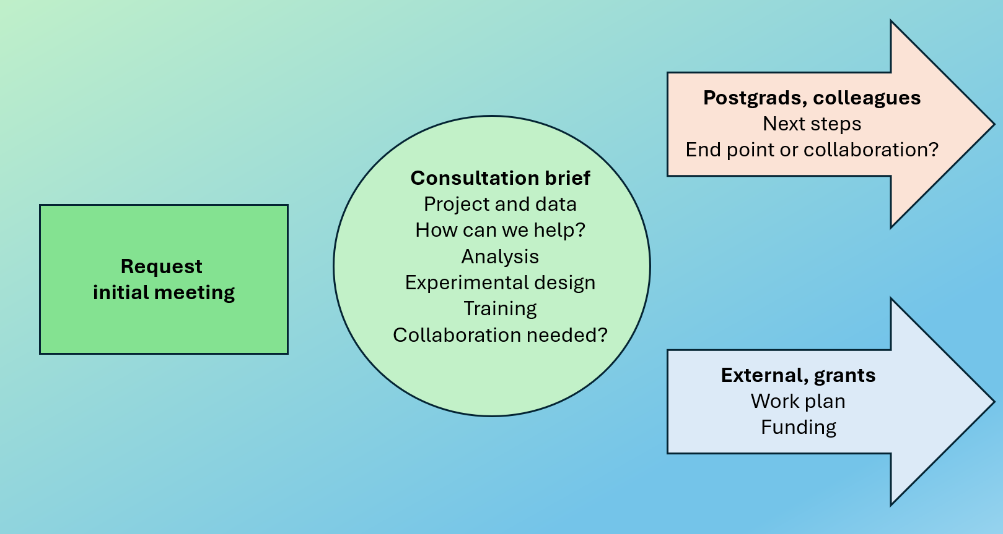
All service begins with a Consultation Brief
The Service offers a range of professional consultation support, including Consultation Briefs for short-term advice and more extensive Collaborations involving manuscript preparation, grant preparation, and expert personnel available for more extensive project contributions. All service will begin with an initial Consultation brief. Consultation Briefs are designed to provide immediate guidance on matters such as experimental design, data collection, and data preparation. These consultations are primarily available to postgraduate students and staff. The service is structured to offer precise, timely advice on an as-needed basis, addressing specific questions, problems that arise during the research process and general support needs. Consultation Briefs typically will consist of an initial meeting with one or several follow-up meetings as required.
For sustained support, the service is available for Collaborations where consultants work as active partners in the research process. Collaborations include support for experimental design, statistical analysis, data engineering, and scientific computing. Here the Service will provide input for the preparation of manuscripts and grant proposals, ensuring that research is analytically sound and communicated effectively. Collaborations may also involve the preparation of data dashboards, data visualisations, and cloud automation to create complex computational workflows. Consultants in these cases may contribute to publications, with recognition of their contributions through authorship were intellectual contributions merit it and by prior agreement. Statistical software guidance is provided throughout the project lifecycle, enabling researchers to choose and use the most appropriate tools for their work, including support for reproducible research and FAIR data principles. Collaborations typically will consist of a planning phase and subsequent engagement and work as specified by mutual agreement, possibly entailing details such as a Terms of Service agreement, a Non-Disclosure Agreement, or other documents as required.

Clients, Roles, and Acknowledgment of Contribution
The service is open to a diverse clientele. Internal clients include Master of Research and PhD postgraduate students, as well as postdoctoral researchers and faculty members. In addition to serving the internal research community, the Service extends to external stakeholders, including industry partners, government agencies, non-governmental organisations, and other external entities. External clients are subject to the same professional standards and practices as internal clients, ensuring consistency and quality in the services provided.
Both consultants and clients have clearly defined roles and responsibilities. Consultants will provide expert advice on statistical and data science issues and ensure that confidentiality and data security are maintained throughout the engagement. Their role extends beyond consultation, supporting clients through all stages of the research process. Clients are expected to provide clean and well-prepared data, and to ensure that research questions and contextual information are communicated clearly at the outset of the consultation. Furthermore, clients are required to adhere to agreed timelines and to maintain active communication with consultants throughout the process.
Clients are expected to acknowledge the consulting Service in research outputs, including dissertations, theses, and academic publications. Where a consultant has made substantial intellectual contributions, authorship should be discussed and agreed as appropriate. Such arrangements should be discussed early in the collaboration process to ensure clarity and mutual understanding between clients and consultants.

Privacy and Data Security
The service is committed to upholding the highest standards of data protection and privacy. All data provided by clients will be managed in compliance with Harper Adams University's data protection policies. Consultants will ensure that sensitive research data is handled with the utmost confidentiality, with access restricted to authorised personnel only. The service does not offer a long-term data repository, and data will only be retained for the duration of the project unless otherwise agreed with the client. Once a project is completed, all data will be securely deleted unless the client specifically requests an extended retention period. Under no circumstances will data be shared without the explicit consent of the client. The Service will participate in formal Non-Disclosure Agreements where required.

Terms of Service
All clients must initiate the consulting process by submitting a formal request form. This form must detail the scope of the project, the research questions, and any requirements specific to the project. Once a request has been submitted, an initial consultation will be scheduled to define the scope of support, and the resources required and whether the support constitutes a Consultation Brief or a Collaboration. Internal clients, including students and faculty, may access the service without charge, provided that departmental funding (e.g. to support Consultation Briefs for postgraduate students) or grant funding are available to cover staff costs. External clients are subject to a fee-for-service model, with rates determined by the complexity and duration of the consultation. All fees will be communicated to the client in advance, ensuring full transparency.
Meeting protocols are clearly defined. Consultation Briefs are typically funded via Department budgets or, e.g., via Quality-Related funding. For Collaborations, an initial short meeting is offered free of charge and to determine the scope of work, including resources required to fund it, and ultimately whether Collaboration will occur. For ongoing projects, costing will be determined according to the time spent and the complexity of the work. Clients are encouraged to engage in regular communication with the Service to ensure that all aspects of the project are progressing as expected.

Communication and Scheduling
Consultation Briefs are scheduled on a first-come, first-served basis. However, priority is given to ongoing Collaborations where clients have made prior commitments to work with the service over an extended period. All clients must ensure that they allow sufficient time for consultations and data analysis, particularly for complex research projects. Requests for consultation should be made well in advance of any project deadlines, with an eight week notice period recommended for large or complex projects. Urgent requests will be accommodated if the timelines are deemed feasible.
Clients are expected to communicate deadlines clearly to the Service, and consultants will work to provide timely feedback throughout the research process. However, delays may occur due to data complexity or high demand for services. Clients are advised to submit support requests as early as possible to avoid delays.

Capacity Building and Training
The Statistics and Data Science Consulting Service at Harper Adams University supports student and staff capacity building by providing ad hoc training opportunities. These initiatives include the weekly Harper Adams R User Group (HARUG!), which has been running for several years with a typical attendance of 15-20 postgraduate students and staff. HARUG has held 165 meetings in the past five years, offering a platform for developing skills in R programming and statistical analysis (see HARUG website).
In addition to HARUG, the Service offers short courses such as the “Friendly R Stats Bootcamp”, designed for all users to enhance their proficiency in statistical methods using R (see Bootcamp website). These sessions ensure that the university community have access to relevant training, fostering a culture of continuous learning and methodological rigour in research.

Harper Adams Dataverse
The Harper Adams Statistics and Data Science Consulting Service for curate and administrate the Harper Adams Dataverse.
Dataverse is an online, open-source data repository platform designed for the management, sharing, and preservation of research data. It allows researchers to deposit datasets, metadata, and related materials in a secure and organised manner, promoting transparency and reproducibility in research. Dataverses provide tools for data citation, version control, and access control, enabling researchers to manage permissions and track usage. The platform supports a wide range of data types and formats, facilitating interdisciplinary collaboration and data integration while ensuring compliance with data management policies and best practices.
The Harvard Dataverse is an open-source data repository platform hosted by the Institute for Quantitative Social Science at Harvard University, designed to facilitate the storage, sharing, and preservation of research data. It provides a secure and organised environment for researchers to deposit datasets, metadata, and supplementary materials, ensuring transparency, reproducibility, and long-term accessibility. The platform supports data citation, version control, and access management, allowing researchers to set permissions and monitor dataset usage. The Harvard Dataverse accommodates various data formats and types, fostering interdisciplinary collaboration and compliance with research data management best practices.
The Harper Adams Dataverse, hosted within the Harvard Dataverse, is a secure and robust platform for managing, storing, and preserving research data in accordance with high curation standards. It supports researchers and students at Harper Adams University by providing a reliable repository for dataset publication, ensuring long-term accessibility and discoverability. The platform assigns Digital Object Identifiers (DOIs) to datasets, enabling precise citation and enhancing the visibility of the University's research outputs within the global academic community. This approach ensures that all data are uniquely identifiable, contributing to the transparency and reproducibility of research.

